|  |  |
| --- | --- |
| Reference summary | -manchester united have made bastian schweinsteiger their top summer target.  -louis van gaal eyes bastian schweinsteiger reunion at old trafford. |
| LSTM seq2seq | -manchester united have been linked with a move to manchester united. |
| BART-base | -manchester united have made bastian schweinsteiger their top summer target. |
| BART-large | -bastian schweinsteiger is thought to be keen on joining his former boss louis van gaal at old trafford. |
| T5-small | -manchester united have made bastian schweinsteiger their top summer target.  -the schweinsteiger is thought to be keen. |
| T5-base | -manchester united have made bastian schweinsteiger their top summer target.  -the schweinsteiger is thought to be keen. |
| T5-large | -manchester united have made bastian schweinsteiger their top summer target.  -schweinsteiger is thought to be keen on. |

|  |  |  |  |
| --- | --- | --- | --- |
| Model | ROUGE-1 | ROUGE-2 | ROUGE-L |
| LSTM | 0.12 | 0.02 | 0.11 |
| BART-base | 0.22 | 0.08 | 0.20 |
| BART-large | 0.27 | 0.13 | 0.25 |
| T-small | 0.27 | 0.13 | 0.26 |
| T5-base | 0.28 | 0.13 | 0.27 |
| T5-large | 0.28 | 0.13 | 0.26 |

|  |  |  |  |
| --- | --- | --- | --- |
| Model | # Parameters | Pretrained data | Finetune data |
| LSTM | 28M | - | CNN/Dailymail |
| BART-base | 139M | XSum | CNN/Dailymail |
| BART-large | 406M | XSum | - |
| T5-small | 60M | C4 | - |
| T5-base | 220M | C4 | - |
| T5-large | 770M | C4 | - |

|  |  |  |  |  |  |  |
| --- | --- | --- | --- | --- | --- | --- |
| Model | ROUGE-1 | ROUGE-2 | ROUGE-L | # Parameters | Pretrained data | Finetune data |
| LSTM | 0.12 | 0.02 | 0.11 | 28M | - | CNN/Dailymail |
| BART-base | 0.22 | 0.08 | 0.20 | 139M | XSum | CNN/Dailymail |
| BART-large | 0.27 | 0.13 | 0.25 | 406M | XSum | - |
| T-small | 0.27 | 0.13 | 0.26 | 60M | C4 | - |
| T5-base | 0.28 | 0.13 | 0.27 | 220M | C4 | - |
| T5-large | 0.28 | 0.13 | 0.26 | 770M | C4 | - |

|  |  |
| --- | --- |
| Story | The label on the package claimed that it contained T-shirts and baby toys. When customs officials in Sydney scanned the parcel, they found five pythons and two venomous tarantulas.  But when customs officials in Sydney X-ray scanned the parcel, they found instead five pythons and two venomous tarantulas. On Tuesday, authorities raided the house in Sydney to which the parcel had been addressed. Officials seized evidence but expect to file charges later, the customs agency said. Importing live animals without a permit is illegal in Australia and can yield a 10-year prison sentence and a fine of 110,000 Australian dollars ($92,000 U.S.). The parcel was sent from the United States last week, but officials would not say specifically where it had been mailed from. The snakes were wrapped within white calico bags and the spiders were packed in clear plastic containers, the customs agency said.  The creatures were later killed because they posed a quarantine risk, the agency said in a press release. It titled the press release: "Spiders and snakes on a plane." |
| Summary | -Customs officials in Australia find pythons and tarantulas in package  -The parcel had been sent from the United States  -The creatures were later killed because they posed a quarantine risk |

|  |  |
| --- | --- |
| Story | The label on the package claimed that it contained T-shirts and baby toys. When customs officials in Sydney scanned the parcel, they found five pythons and two venomous tarantulas.  But when customs officials in Sydney X-ray scanned the parcel, they found instead five pythons and two venomous tarantulas. On Tuesday, authorities raided the house in Sydney to which the parcel had been addressed. Officials seized evidence but expect to file charges later, the customs agency said. Importing live animals without a permit is illegal in Australia and can yield a 10-year prison sentence and a fine of 110,000 Australian dollars ($92,000 U.S.). (cont.) |
| Summary | -Customs officials in Australia find pythons and tarantulas in package  -The parcel had been sent from the United States  -The creatures were later killed because they posed a quarantine risk |

|  |  |
| --- | --- |
| Reference summary | -the reds want swansea striker wilfried bony to boost their attack.  -petr cech and jack butland are being considered by the anfield club. |
| LSTM seq2seq | -liverpool have been linked with a move to the premier league. |
| BART-base | -liverpool are continuing to discuss the possibility of new additions to their squad should brendan rodgers get money to. |
| BART-large | -liverpool are continuing to discuss the possibility of new additions to their squad.  -a goalkeeper and striker remain the objectives but key could be the departure. |
| T5-small | -liverpool are continuing to discuss the possibility of new additions to their squad should brendan rodgers get money to spend. |
| T5-base | -liverpool are continuing to discuss the possibility of new signings.  -a goalkeeper and striker remain the objectives for brendan rodgers. |
| T5-large | -liverpool are continuing to discuss the possibility of new additions to their squad should brendan rodgers get money to spend.  -schweinsteiger is thought to be keen on. |

|  |  |
| --- | --- |
| **Reference Summary** | The cat was under the bed |
| **System Summary** | The cat was found under the bed |

|  |  |
| --- | --- |
| Precision | 6/7 = 0.86 |
| Recall | 6/6 = 1 |
| F1 | 0.925 |

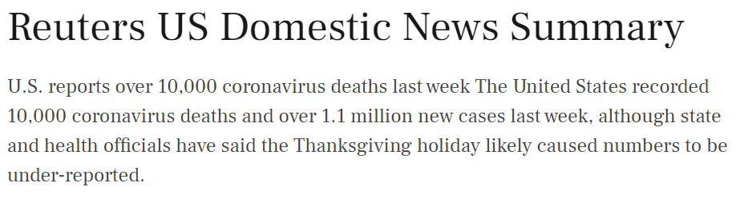



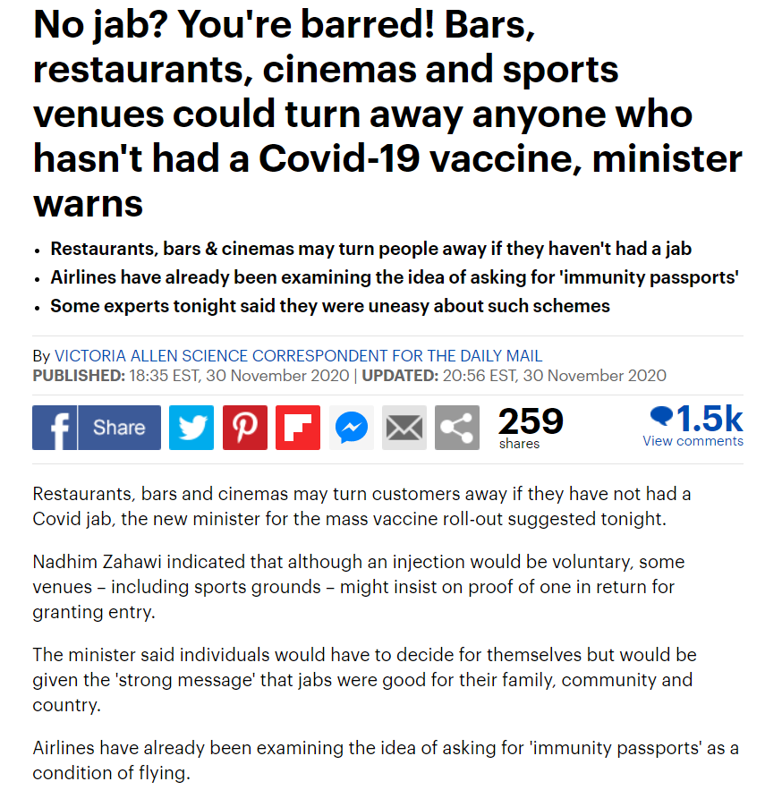

**Summaries**